RedbridgeCVS Report on Public Meetings held for Redbridge Fairness Commission 2015.
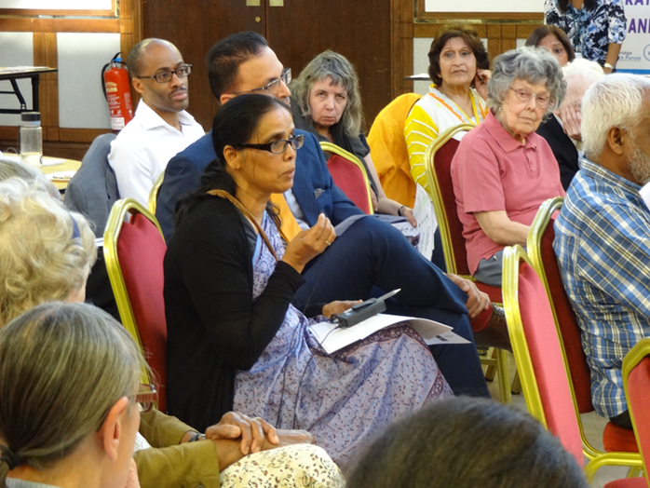

In 2015 RedbridgeCVS was commissioned by Redbridge Council to deliver three public meetings to support and inform the work of the Redbridge Fairness Commission. The specification required that these meetings be run using “open space techniques” in order to “seek the views of Redbridge residents on aspects of service delivery in Redbridge that they deem unfair, inequitable or inappropriate to the needs of residents.”
Open Space technology is a method for running meetings. In Open Space meetings, events and organizations, participants create and manage their own agenda of parallel working sessions around a central theme of strategic importance. OpenSpaceWorld.Org describes the purpose of this method as follows: “Open Space Technology is one way to enable all kinds of people, in any kind of organization, to create inspired meetings and events. Over the last 20+ years, it has also become clear that opening space, as an intentional leadership practice, can create inspired organizations, where ordinary people work together to create extraordinary results with regularity.” Open Space technology pioneer Harrison Owen says that there are four Rules and one Law for open space meetings. The Four Rules state: i) whoever come are the right people, ii) whatever happens is the only thing that could have, iii) whenever it starts is the right time, and iv) when it’s over, it’s over. The Law of Two Feet states that: “If, during the course of the gathering, any person finds themselves in a situation where they are neither learning nor contributing, they must use their feet and go to some more productive place.”
RedbridgeCVS delivered the three public meetings using this methodology and a draft Agenda and Facilitators’ Guide are attached as Appendices 1 and 2. We sought to promote the meetings with the single theme of “Fairness in Redbridge” to allow those attending the meetings to contribute their ideas in the early part of the meeting so that themed workshops (with themes emerging from the initial discussions) could take place as the main part of the meeting.
The meetings were planned to take place at different locations within Redbridge (each close to public transport and in accessible venues), and at different times of the week (-we ran one on a weekday evening, one on a Saturday afternoon and one on a weekday). The meetings were as follows:-
Thursday 11th June 2015 7pm – 9 pm
ILFORD ISLAMIC CENTRE
Albert Road Ilford IG1 1HW

Sat 20 June 2015 2.30 pm - 4.30 pm
THE ALDBOROUGH ROOM, FULLWELL CROSS LIBRARY
140 High Street, Barkingside, IG6 2EA

Monday 6th July 2015 2.00 pm – 4.00 pm
REDBRIDGE DRAMA AND TEACHER TRAINING CENTRE
Churchfields, South Woodford, LONDON, E18 2RB

The first meeting was arranged in partnership with Redbridge Faith Forum, and followed immediately after their AGM. The second meeting was arranged in partnership with Barkingside 21. The third meeting was not arranged in partnership, but had an additional focus on enabling people with additional communication needs to take part. We provided BSL signers, an induction loop (for people with hearing aids) and a palantypist (who projected typed text of the discussions live at the meeting).

Notes of these meetings are attached as Appendices 3, 4 and 5. These notes give a breakdown by ward of where those present either live or work. (Signing-in sheets for all the meetings are available on request. Photos of the meeting are attached as Appendix 6. More photos are available on request.)

A total of 120 people (including Councillors, Council officers and RedbridgeCVS staff) attended the three meetings. If we exclude the RedbridgeCVS staff and Councillors/Council officers, a total of 89 “members of the public” attended the public meetings.

A wide range of topics was discussed – with each meeting discussing some unique topics and some that were common to all the meetings. Some key themes that emerged from the meetings were:-
- Fears about ‘digital exclusion’ for those unable or unwilling to use computers to access information, advice, services etc
- People with disabilities feel distant from information, services and decisions. (This was also true for people without disabilities, but to a lesser extent.)
- Difficulties in getting timely GP access
- Support was expressed for voluntary sector services (which are people-centred and offer good value for money) at a time when public sector services are reducing
- Concerns about housing – and, specifically, the lack of genuinely affordable housing in the borough
- Concerns that some Council sub-contractors pay staff at well below the Living Wage

A more detailed list of the concerns raised at the public meetings, clustered under themes, follows:-
A: Health and Social Care:
- GP provision needs to be increased
- Early intervention and prevention services are important
- There is a need to upskill healthcare professionals, particularly around disability
- A healthy voluntary sector is vital
- There should be no cuts in healthcare and spending on Redbridge’s health and social care should be increased
- There is a greater need for “joined up” services (to maximise services’ impact on users, save money and ensure people don’t get ‘lost between the cracks in the system’)
- Older people receive unfair treatment in that those who are cared for by family members are not eligible to receive any support for social care
- Health services – money not recouped for provision of services to non EU citizens
- Health and Social Services need to take on board the vital role of interpreters for deaf people (BSL is a “first language” for most deaf people. Local services do not provide BSL translations)
- Needs of older people with no family support have to be taken into account
- People with disabilities should have a One Stop Shop where they could find out about all available services in one place

B: Education:
- Education should be predominantly under the control of the local authority
- Class sizes should be protected
- Better support and alternative pathways needed for under-achieving students, especially 16+ (ie academic pathways to University are not always appropriate aims for all students)
- Agency teachers should be a last resort
- Redbridge pupils have good achievements – but some of this may be due to the impact of parents paying for private tuition
- Faith schools should offer 50% of places to students of other or no faiths, to encourage a cohesive community

C: Housing and Environment
- More housing is necessary locally - particularly housing which is “genuinely affordable”
- Concern was expressed over the removal of people from the Council’s housing waiting list if they have lived in Redbridge for less than 3 years
- Lack of realistic local housing prospects for young people
- Need for improvements to housing stock to make homes more energy efficient (thereby saving tenants money and protecting the environment)
- New build homes should all be for those in current housing need, not for sale to people planning to buy-to-let
- Greater efforts should be made to ensure families with children in Redbridge schools are not rehoused outside the borough
- Green waste should be composted locally and sold to local people
- Housing – buildings with multiple occupancies do not contribute fairly to Council Tax revenue
- Planning issues – there is a presumption in favour of developers, and too many retrospective planning applications are accepted,

D: Employment and Training
- Need for more apprenticeships and work experience for 16+
- More support to get into work, and for those in work, should be available for people with disabilities
- Job Centre Plus service and advisors need to improve significantly
- There should be more publicity about the work of voluntary and community sector groups so people know what services are available
- Local careers advice needs improving
- More mentors are needed to support those in work/looking for work
- Better employer engagement should be undertaken by Redbridge Council
- There should be a lower retirement age – to give more employment opportunities for younger people
- Taxpayers should not be subsidising big companies who don’t pay Living Wage
- Use of less than Living Wage (and zero hours contracts) for staff delivering contracts (via third parties) for LBR was felt to be ‘unfair’

E: Crime, Policing & Community Safety
- More advice and advocacy on legal issues is required – Redbridge needs a Law Centre
- More needs to be done to address prostitution issues in Ilford Lane
- Fly tipping needs addressing with greater urgency
- The Council should consider introducing a licensing scheme for tradespeople
- Police are visible but not always focusing on what the public want
- Need to educate people more about expectations and services to help: eg publicise illegality of fly tipping, promote Neighbourhood Watch and CCTV etc.
- More policing required at night around public parks

F: Community Engagement / Cohesion
- Concern was expressed about the lack of engagement of young people (and others) in civic life. (Support was expressed for residents associations, which have been in decline for some years)
- There is a perceived lack of transparency in Council decision making
- More should be done to enable dual use of public sector buildings to benefit community groups/organisations
- Need to get responses to communications from all Councillors and Officers. This was reported to be “hit and miss at the moment” with some Councillors and officers better than others at responding to queries and complaints
- Community Cohesion: There should be more efforts by local residents (as well as the Council) to raise awareness of different faiths and cultural practices to bring more community cohesion and harmony

Ross Diamond
9/7/15

