Title of report
Face coverings: when to wear one and how to make your own
From  Ikenna Obianwa  Public Health Manager | Intended for  London Borough of Redbridge and providers, who are preparing to come back to work in support of Redbridge communities.

Table of Contents
What is a face covering? 1
Why use face covering? 2
How to wear and remove a face covering? 2
When to wear a face covering? 2
Exception to wearing a face covering where they are mandated 3
Face coverings at work 4
Making your own face covering 4
Maintaining and disposing of face coverings 4

What is a face covering?
- A face covering is something (anything) which safely covers the nose and mouth. It can be purchased as reusable or single-use face coverings. However, a scarf, bandana, religious garment or hand-made cloth covering may also be used but these must securely fit round the side of the face.
- Face coverings are not classified as PPE (personal protective equipment) which is used in settings to protect wearers against hazards and risks, such as surgical masks or respirators used in medical and industrial settings.
- Face coverings are instead largely intended to protect others, not the wearer, against the spread of infection because they cover the nose and mouth, which are the main confirmed sources of transmission of virus that causes coronavirus infection (COVID-19).

Why use face covering?
- Coronavirus (COVID-19) spreads predominantly by droplets from coughs, sneezes and speaking. These droplets can also be picked up from surfaces
- Wearing a face covering helps reduce the spread of coronavirus droplets in certain circumstances, helping to protect others.
- Face coverings are mainly intended to protect others, not the wearer, from coronavirus (COVID-19) they are not a replacement for social distancing and regular hand washing.

How to wear and remove a face covering?
A face covering should: | When wearing a face covering, please: | When removing a face covering:
- cover your nose and mouth while allowing you to breathe comfortably  - fit comfortably but securely against the side of the face  - be secured to the head with ties or ear loops  - be made of a material that you find to be comfortable and breathable, such as cotton  - ideally include at least two layers of fabric (the World Health Organisation recommends three depending on the fabric used)  - unless disposable, it should be able to be washed with other items of laundry according to fabric washing instructions and dried without causing the face covering to be damaged | - wash your hands thoroughly with soap and water for 20 seconds or use hand sanitiser before putting a face covering on  - avoid wearing on your neck or forehead  - avoid touching the part of the face covering in contact with your mouth and nose, as it could be contaminated with the virus  - change the face covering if it becomes damp or if you’ve touched it | - wash your hands thoroughly with soap and water for 20 seconds or use hand sanitiser before removing  - only handle the straps, ties or clips  - do not share with someone else to use  - if single-use, dispose of it carefully in a residual waste bin and do not recycle  - if reusable, wash it in line with manufacturer’s instructions at the highest temperature appropriate for the fabric  - wash your hands thoroughly with soap and water for 20 seconds or use hand sanitiser once removed

When to wear a face covering?
- In England, it is a requirement by law to wear a face covering in the following settings: Public Transport; Shops and Supermarkets as of 24 July 2020
- Penalty for non-compliance to the law can lead to denial of service or issuing a fine of £100 (halving to £50 if paid within 14 days). Transport for London authorised officers and the Police are authorised to issue fines.

Exception to wearing a face covering where they are mandated
- In settings where face coverings are mandated in England, there are some circumstances, for health, age or equality reasons, whereby people are not expected to wear face coverings in these settings.
- A GP note is not required for face covering exemptions
- Everyone do not need to wear a face covering if you have a legitimate reason not to. This includes:
- young children under the age of 11
- not being able to put on, wear or remove a face covering because of a physical or mental illness or impairment, or disability
- if putting on, wearing or removing a face covering will cause you severe distress
- if you are travelling with or providing assistance to someone who relies on lip reading to communicate
- to avoid harm or injury, or the risk of harm or injury, to yourself or others
- to avoid injury, or to escape a risk of harm, and you do not have a face covering with you
- to eat or drink, but only if you need to
- to take medication
- if a police officer or other official requests you remove your face covering

- There are also scenarios when you are permitted to remove a face covering when asked:
- If asked to do so by shop staff for the purpose of age identification
- If speaking with people who rely on lip reading, facial expressions and clear sound. Some may ask you, either verbally or in writing, to remove a covering to help with communication

Face coverings at work
- There is no universal face coverings guidance for workplaces because of the variety of work environments in different industries.
- It is important to note that employers must make sure that the risk assessment for their business addresses the risks of COVID-19 using BEIS guidance to inform decisions and control measures including close proximity working.
- In many workplaces, the risks from coronavirus (COVID-19) has been managed through a hierarchy or system of control including social distancing, high standards of hand hygiene, increased surface cleaning, fixed teams or partnering, and other measures such as using screens or barriers to separate people from each other

Making your own face covering
- Instructions on how to make a cloth face covering are widely available online. You can also find how to make face covering on your favourite TV programmes
- Evidence suggests that the risk of transmission may be reduced by using thicker fabrics or multiple layers. However, the face covering should still be breathable.

Maintaining and disposing of face coverings
- Do not touch the front of the face covering, or the part of the face covering that has been in contact with your mouth and nose.
- Once removed, store reusable face coverings in a plastic bag until you have an opportunity to wash them.
- If the face covering is single use, dispose of it in a residual waste bin. Do not put them in a recycling bin.
- Clean any surfaces the face covering has touched using normal household cleaning products. If eating in a restaurant, for example, it is important that you do not place the face covering on the table.
- Wash face covering regularly and follow the washing instructions for the fabric. Use normal detergent or wash and dry it with other laundry. Throw away face covering if it is damaged.
Promotion
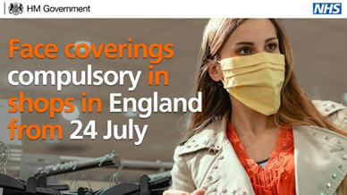 | 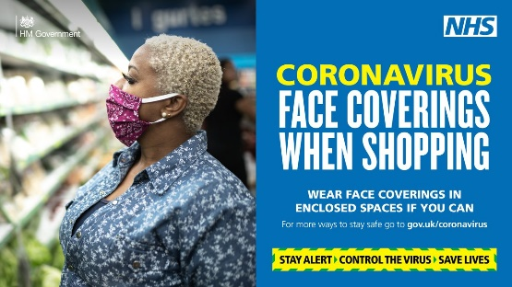

14 July 2020
ENDS

https://www.gov.uk/government/publications/face-coverings-when-to-wear-one-and-how-to-make-your-own/face-coverings-when-to-wear-one-and-how-to-make-your-own#exemptions-to-wearing-a-face-covering-where-they-are-mandated

