**Programme   
10:30 am** - Tai Chi (Taster Exercise Class) - Tai Chi, combines deep breathing and relaxation with flowing movements.

**11:30 am** - Nutrition Talk - This workshop will allow you to assess your nutrition know-how and give you tips on easy ways to improve your diet, manage your weight, boost your energy level, and prevent disease.

**12:15pm** – Lunch

**1:30pm** – Relaxation workshop – NELFT Talking Therapies will be running this workshop, teaching you a range of useful techniques.

**Even if you don’t want to attend the workshops, please come along as throughout the day there will also be taster complementary therapies, health checks and a range of information stalls with lots of useful information*. It would be helpful if you could let us know you’ll be attending by 6th June 2018, for catering purposes.***

The theme for this year’s Carers Week is supporting carers to be Healthy and Connected. Redbridge Carers Support Service will be holding a Health and Wellbeing event on **Wednesday 13th June 2018** at the **City Gates Church, 3rd Floor, 25-29 Clements Road, Ilford, IG1 1BH, 10:15am – 3.00pm.**

**Redbridge Carers Support Service Health and Wellbeing Event Wednesday 13th June 2018**

[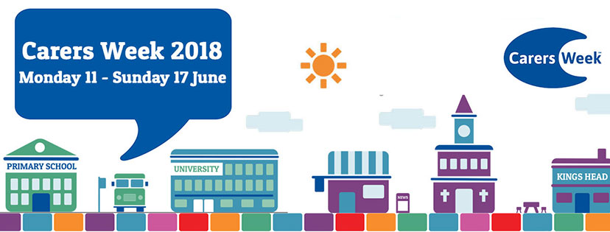](https://www.facebook.com/122786224398306/photos/1701804376496475/)

