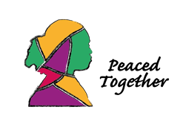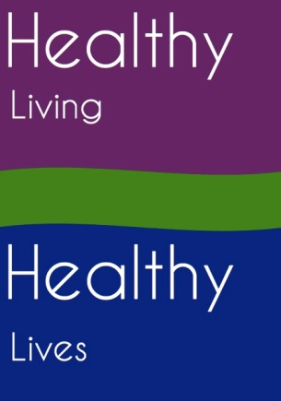

Peaced Together Registration and Booking Form

Commencing Thursday 2 July 2020
At home via zoom starting 7pm

Surname ........................................................ Christian Names.........................................................
Town/Village.................................................. Postcode .............................
Email ...................................................................... Telephone............................................

Please reserve a place for me on the above course.
I understand that the course is provided free and due to COVID19, lockdown and social distancing, it will be offered remotely.
I understand that written course materials will be emailed to me each week and that I will have to provide all materials required for the craft projects and scrapbooking.
I understand that in booking I commit to attending each session.

I understand that in order to participate, I need an email address and a device connected to the internet which is capable of providing Zoom as a platform

Signed ........................................................................................ Date .............................................

Please return to our Project Manager by email

stephanie@healthylivinghealthylives.com

Stephanie O’Leary
Peaced Together Project Manager
Healthy Living Healthy Lives CIC
The Office, Love Lane, Ongar, Essex, CM5 9BL

Phone: 01277 364276

Further general information may be found at www.peacedtogether.co.uk

You are accessing one of our services. We have a legitimate reason to collect the above data. We will maintain contact via email/phone and/or social media if you wish to continue an ongoing relationship with us. You have the right to inform us at any time after the course has finished that you do not wish to maintain contact and we will remove your contact details from our database

