THE REDBRIDGE COMPACT
“Good Practice for Working Together”
ANNUAL REPORT 2015-2016
Redbridge Compact is a joint agreement
between voluntary groups and public bodies
and exists to help the partners improve
their relationship for mutual advantage and
community gain.
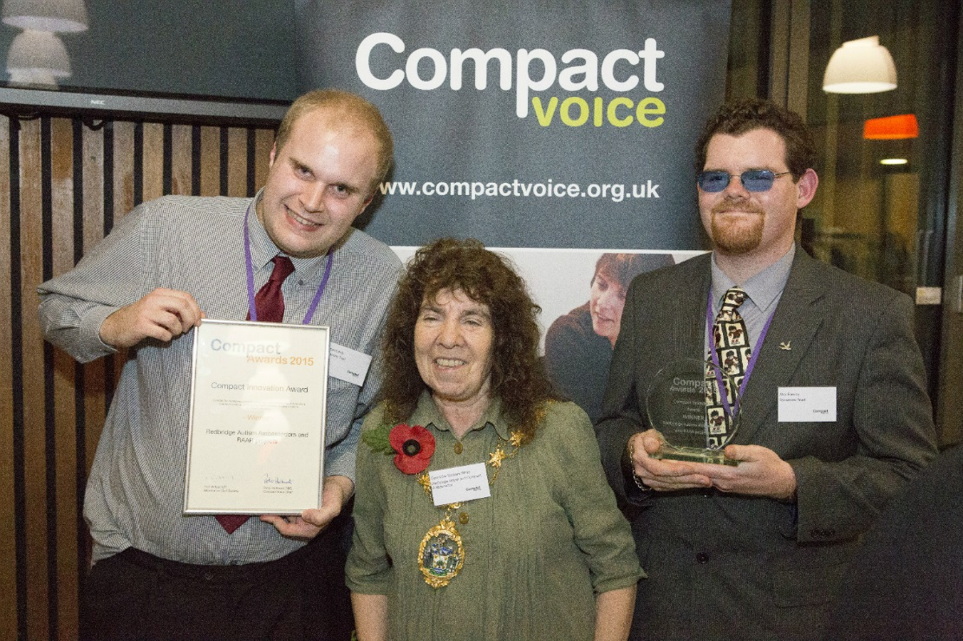
The front cover shows the Mayor of Redbridge together with Robert Lamb and Alex Rowley from the Redbridge Autism Ambassadors and RAAR projects (Sycamore Trust), on winning a national Compact Award for Innovation in November 2015.

Introduction
Redbridge has a thriving voluntary and community sector, which makes a significant contribution to public life and the development of quality local services. Much of this work is the result of the strong, healthy and vibrant partnerships between the voluntary sector and the public sector.
In 2015-16 Redbridge formally adopted a new Compact. This built on the previous document which has helped foster strong relationships between the local voluntary and public sectors. We were also delighted that NELFT (North East London NHS Foundation Trust) also signed up to the Compact, as a reflection of the value they place on working in partnership with the voluntary sector.
Throughout the year a group of nominees from the signatory organisations, along with a representative sent by the local Public and Voluntary Sectors’ Partnership, met as a local Compact Champions group to oversee compliance with the spirit and wording of the Compact document via three Champions meetings and a range of online discussions and smaller face to face meetings. This work included the development, implementation and monitoring of an Action Plan, discussions of possible breaches of the Compact and the promotion of local examples of best practice.
Five local projects were shortlisted for the national Compact Awards 2015/16 – with two local groups winning individual category awards. Redbridge Faith Forum was shortlisted in the Advancing Equality category, but was beaten in this category by the HENCEL Deaf Inclusion Project, led by Redbridge Healthwatch, for its work supporting members of the deaf community to raise awareness of barriers to accessing health services, and for making a real impact in improving access for deaf patients. The Redbridge TB Partnership (led by Public Health Redbridge and RedbridgeCVS) was nominated in the Compact Engagement Award category for its innovative approach to engaging local people and the Autism Ambassadors and Redbridge Autism Awareness Roadshow (led by Sycamore Trust) won the Compact Innovation Award for empowering young people with autism to raise autism awareness and improve the accessibility of buildings and services in Redbridge for autistic people – beating RedbridgeCVS’s Fit For Fun exercise project in this category.

Redbridge Compact Champions Group
The Compact Champions group is made up of senior officers from the Council, the NHS, the local Police service, the local Fire service, RedbridgeCVS, Redbridge Faith Forum and a (voluntary sector) nominee from the Redbridge Public and Voluntary Sectors’ Partnership. It is scheduled to meet at least twice a year to discuss and review the implementation of the Compact, to look for opportunities for collaborative working, to identify any under-performance and identify remedial actions as necessary. It oversees the development and implementation of a three-year Action Plan.

The Compact Champions for the year were:-
Ross Diamond (RedbridgeCVS) - Chair
Chief Inspector John Fish (Metropolitan Police) – Vice Chair
Steve Brown (Fire Service Redbridge)
Tom Hook / John Turkson (LBR)
Jacquie Grieve / (Redbridge Faith Forum)
Rita Chadha (Public and Voluntary Sectors’ Partnership)
Khalil Ali (NHS ONEL)
Bob Edwards (NELFT)

Officer Support was provided by Shila Barber and Michelle Epstein (LBR).
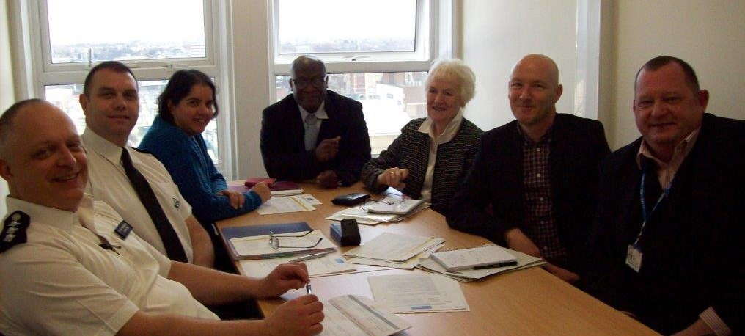

The Redbridge Compact Champions at work:
From left to right: Chief Inspector John Fish (Metropolitan Police Service) Steve Brown (Borough Commander, Fire Service Redbridge); Rita Chadha (Redbridge Public and Voluntary Sectors’ Partnership); John Turkson (London Borough of Redbridge); Jacqui Greave (Redbridge Faith Forum); Ross Diamond (RedbridgeCVS); Bob Edwards (NELFT).
In addition to the Compact Champions, Redbridge’s Mayor is asked each year to take on the role of “Compact Ambassador” with responsibility for promoting the value and use of the Compact by all parties.
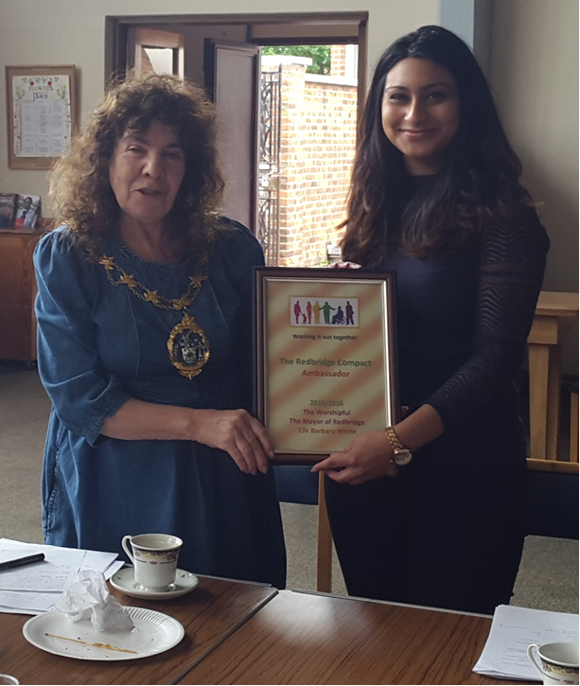
Mayor of Redbridge, Barbara White formally accepting the role of Compact Ambassador for 2015-16 from Cllr Farah Hussain, at the Redbridge public and Voluntary Sectors’ Partnership away day.

Achievements for 2015-16
This year the Compact Champions formally signed off the “refreshed” Redbridge Compact. This is attached as Appendix 1. The Action Plan for the year is attached as Appendix 2. In addition to the activities shown there, we are proud to note that five Redbridge projects were shortlisted for national Compact Awards, winning two of these. All the shortlisted groups were invited to attend a Full Council meeting to celebrate their successes and were welcomed to a reception in the Town Hall by the Mayor’s consort.

Compact Advancing Equality Award
Awarded for demonstrating an outstanding commitment to equality: through promoting services, activities, or events which help advance equality of opportunity, or actively seek to tackle and challenge discrimination.
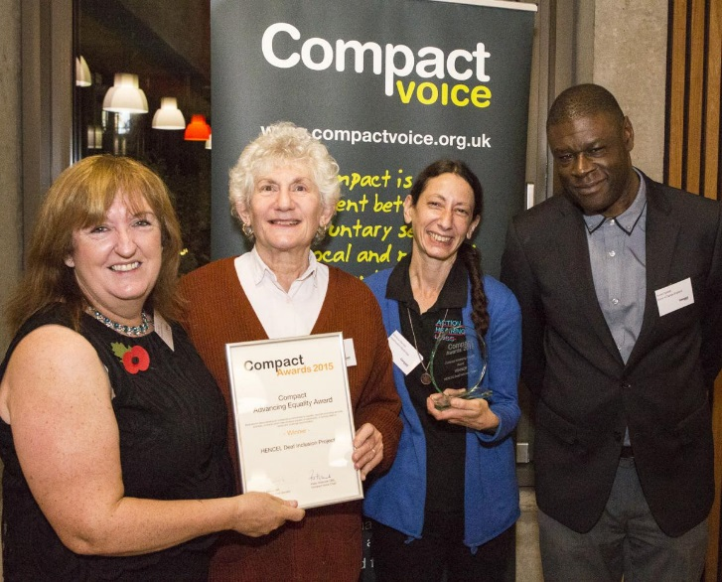 | Winner: HENCEL Deaf Inclusion Project  For supporting members of the deaf community to raise awareness of barriers to accessing health services, and for making a real impact in improving access for deaf patients in North, Central and East London.

Compact Innovation Award
Awarded for developing a new on-going approach to improving or supporting Compact working, particularly for demonstrating creative solutions to difficult situations.
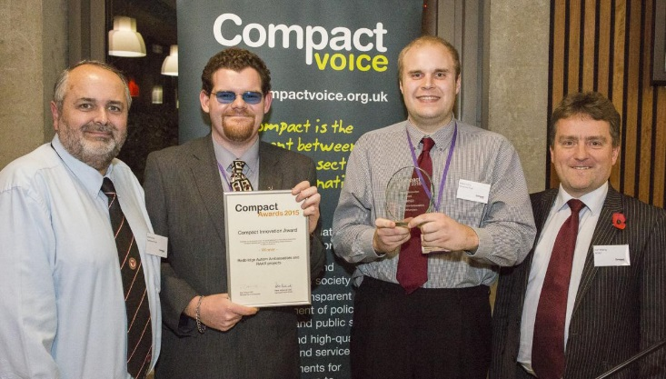 | Winner: Autism Ambassadors and Redbridge Autism Awareness Roadshow  For empowering young people with autism to raise autism awareness and improve the accessibility of buildings and services in Redbridge for autistic people.

Also shortlisted:
Compact Advancing Equality Award: Redbridge Faith Forum
Compact Engagement Award: Redbridge TB Partnership
Compact Innovation Award: Redbridge Fit for Fun (RedbridgeCVS)

Compliance Issues
A number of specific issues of concern were discussed by the Champions over the year. There was, however, no use of the formal Disputes Resolution procedure.

Meetings for the Year
9th June 2015:
Ross Diamond (Chief Executive Officer, RedbridgeCVS) was elected Chair for the year. Chief Inspector John Fish (Metropolitan Police) was elected Vice Chair.

The meeting signed off on the final version of the Compact document that had been extensively revised and consulted upon. This would be formally ‘launched’ at the Public and Voluntary Sectors’ Partnership Away Day event in the summer of 2015.

All signatory bodies agreed to put up posters to ensure their colleagues were aware of the Compact and how it can be used. The meeting also agreed to develop and adopt a revised Disputes Resolution Procedure for investigating potential breaches of the Compact, with the desire to resolve conflicts informally and early whenever possible. It was agreed that all public sector agencies would send details of their forthcoming consultations to RedbridgeCVS for publishing to its website and sharing with voluntary sector colleagues.

The meeting also noted that there were insufficient resources available for RedbridgeCVS to produce a Voluntary Sector Strategy for Redbridge. RedbridgeCVS was also keen to ensure that any such strategy was “owned” by the Council (and other public sector bodies if possible) and outlining their vision for the voluntary sector – rather than having a strategy which contained just the aspirations of the local voluntary sector.

The Action Plan was updated.

3 September 2015:
The meeting discussed and agreed the new Disputes Resolution process (attached as Appendix 3).

Questions for the first annual “relationship survey” to consider the relationships between local voluntary and public sector agencies were agreed. These were then included as part of RedbridgeCVS’ annual survey of its users which also asked if groups had used the Compact in the past. These questions will be asked annually and any significant changes will be discussed by the Compact Champions.

Have you used the Redbridge Compact?
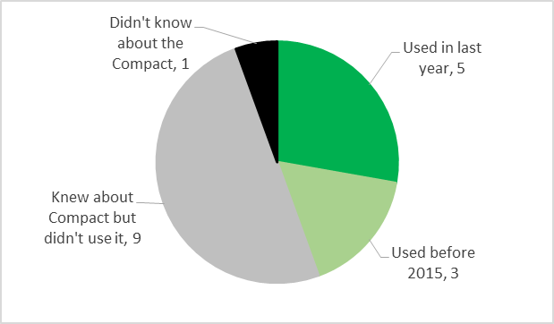

How has your organisation’s relationship with these public sector bodies changed in the last twelve months?
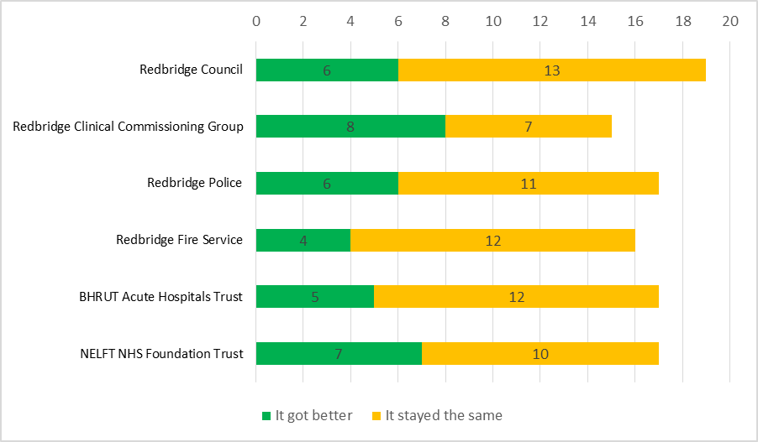

It was interesting to note that, despite austerity affecting all public sector agencies, no respondents reported that their relationship with local public sector agencies had deteriorated during the year.

Draft nominations for the national Compact Awards were considered with one potential submission rejected as not having enough “partnership” elements, and others requiring further work before submission. In the end, five local projects were submitted, all of which were shortlisted.

The meeting also thanked Shila Barber who was leaving LBR after many years of work with the local voluntary sector.
The Action Plan was updated.

7th March 2016:
Bob Edwards from NELFT was welcomed to his first Compact meeting, as NELFT had agreed to become a Compact signatory.

The meeting received the news of the national Compact Awards and congratulated the winners and the shortlisted groups.

The meeting received an update on LBR’s ongoing grants review.

There was a discussion about the consultation for Redbridge’s Local Plan. It was noted that this was an ongoing iterative process linking to statutory timetables so that individual consultation periods would often not meet the recommended 12 weeks, but the cumulative consultation periods meant that this consultation could still be Compact-compliant. There was also a discussion of how LBR uses is Community Infrastructure Levy (CIL) and whether voluntary organisations can help shape how this money is spent. It was agreed that RedbridgeCVS would liaise with the Chief Executive of LBR regarding this matter.

The Action Plan was updated.

